Two Pointers Technique

Two pointers is really an easy and effective technique which is typically used for searching pairs in a sorted array.
Given a sorted array A (sorted in ascending order), having N integers, find if there exists any pair of elements (A[i], A[j]) such that their sum is equal to X.
We take two pointers, one representing the first element and other representing the last element of the array, and then we add the values kept at both the pointers. If their sum is smaller than X then we shift the left pointer to right or if their sum is greater than X then we shift the right pointer to left, in order to get closer to the sum. We keep moving the pointers until we get the sum as X.

The idea of this technique is to begin with two corners of the given array. We use two index variables left and right to traverse from both corners.

Initialize: left = 0, right = n – 1
Run a loop while left < right, do the following inside the loop

Compute current sum, sum = arr[left] + arr[right]
If the sum equals the target, we’ve found the pair.
If the sum is less than the target, move the left pointer to the right to increase the sum.
If the sum is greater than the target, move the right pointer to the left to decrease the sum.
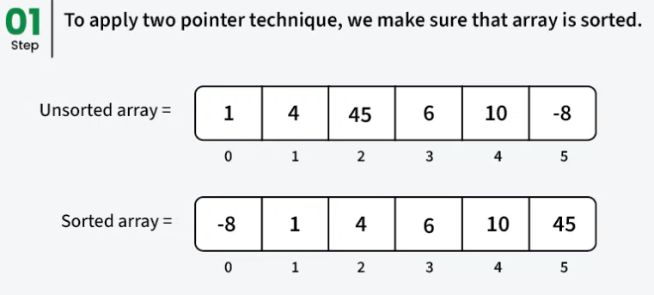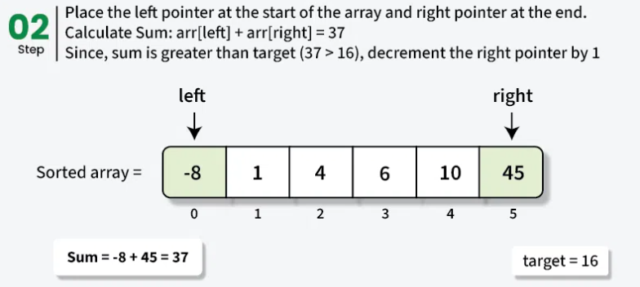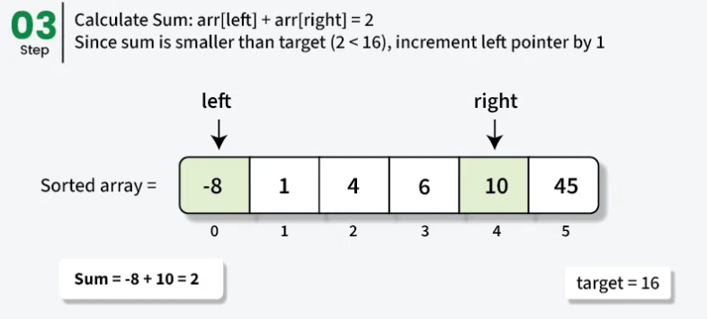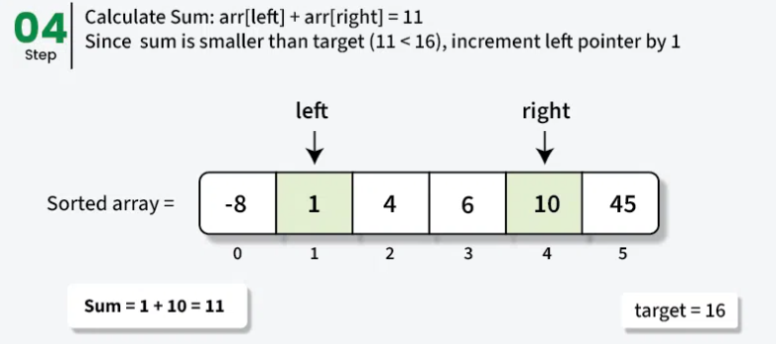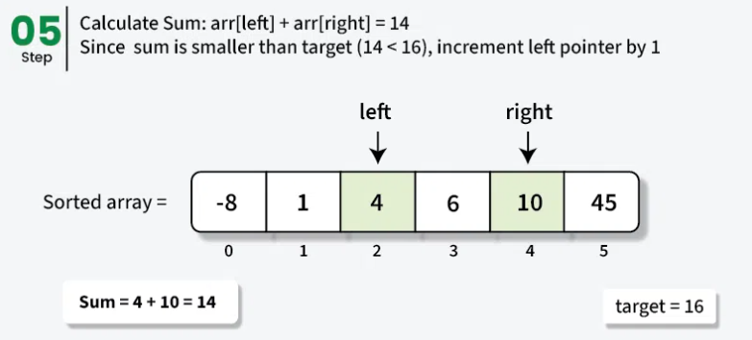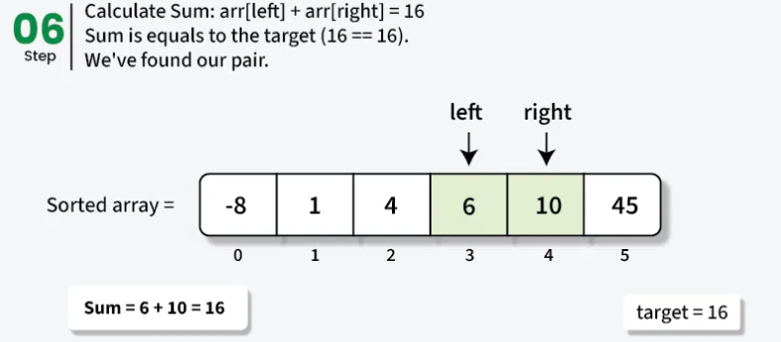

Navie method | 2 Pointer method
class Demo {  static boolean twoSum(int[] arr, int target){  int n = arr.length;  for (int i = 0; i < n; i++) {  for (int j = i + 1; j < n; j++) {  if (arr[i] + arr[j] == target) {  return true;  }  }  }  return false;  }  public static void main(String[] args){  int[] arr = { 0, -1, 2, -3, 1 };  int target = -2;  if (twoSum(arr, target))  System.out.println("true");  else  System.out.println("false");  }  } | import java.util.Arrays;  class GfG {  static boolean twoSum(int[] arr, int target){  Arrays.sort(arr);  int left = 0, right = arr.length - 1;  while (left < right) {  int sum = arr[left] + arr[right];  if (sum == target)  return true;  else if (sum < target)  left++; // Move left pointer to the right  else  right--; // Move right pointer to the left  }  return false;  }  public static void main(String[] args){  int[] arr = { 0, -1, 2, -3, 1 };  int target = -2;  if (twoSum(arr, target)) {  System.out.println("true");  }  else {  System.out.println("false");  }  }  }
Complexity:- O(n^2) Time and O(1) Space | Complexity:- O(n) time and O(1) space

